Eduan Van Der Merwe
PRACTICAL 7: ROUTER CONFIGURATION AND INTER-NETWORK COMMUNICATION
Objective
Configure routers and establish communication between networks.
Equipment
- Cisco 1941 Router
- Cisco ISR4331 Router
- Cisco Switches
- PCs

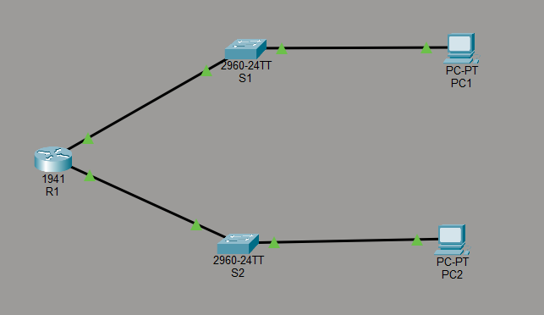
Figure 1: Full topology
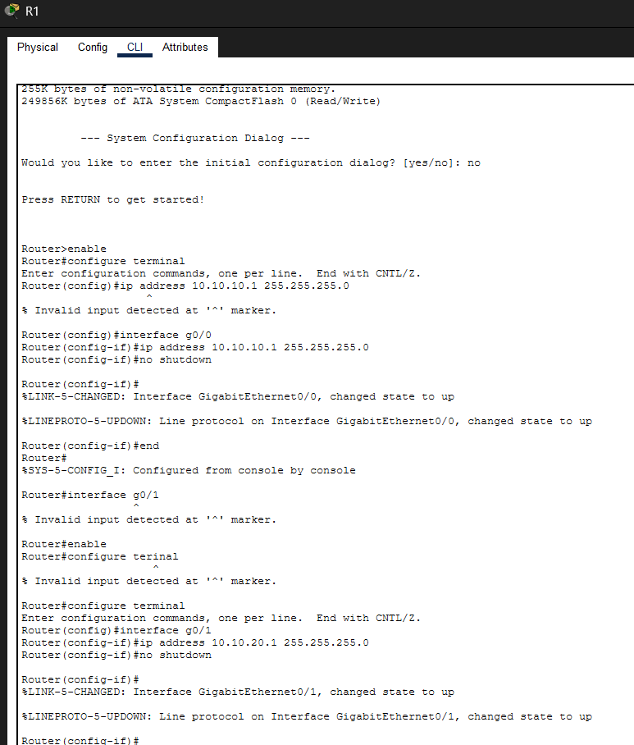
Figure 2: Router 1 Configuration
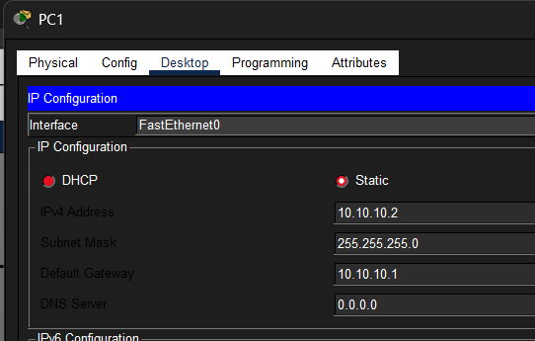
Figure 3: PC1 IP CONFIG
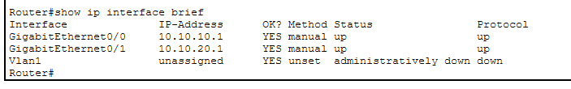
Figure 4: Router show ip interface brief
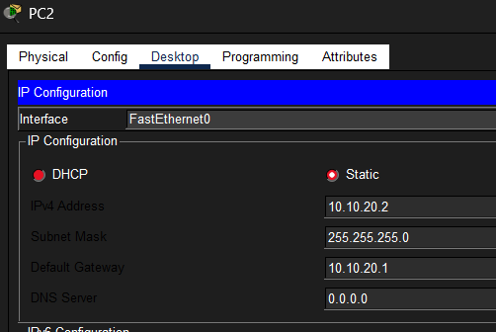
Figure 5: PC2 IP CONFIG
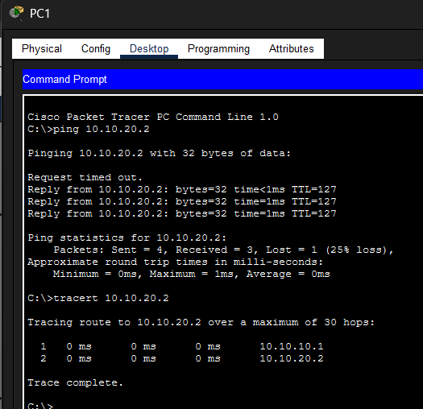
Figure 6: Verification Ping Tracert
Activities
Create two networks:
Network A 1 192.168.10.0/24
Network B 1 192.168.20.0/24
Example Configuration 1 interface g0/0
2 ip address 192.168.10.1 255.255.255.0
3 no shutdown
5 interface g0/1
6 ip address 192.168.20.1 255.255.255.0
7 no shutdown
Verification Commands
1 show ip interface brief
2 ping
3 tracert

Deliverable
Successful communication between both networks.
Assessment Rubric (10 Marks) Criteria | Marks
Router configuration | 4
Interface addressing | 2
Connectivity testing | 2
Documentation | 2
Total | 10

